PROJECT REPORT

by

NAZMUL HOSSAIN

Presented to

Dr. Chu

UNIVERSITY OF HOUSTON

December 2018

## Table of Contents

Table of Contents ii

List of Figures iii

Chapter 1: Project Specification 1

Chapter 2: Model Description 2

Chapter 3: Results and Discussion 4

3.1 Without Chute Blocks 4

3.2 With Chute Blocks 6

Chapter 4: Conclusion 9

## 

## List of Figures

Figure 2.1: Channel Profile 2

Figure 2.2: Cross-section of channel 2

Figure 2.3: Isometric view of channel model(without chute blocks) 3

Figure 2.4: Isometric view of channel model(with chute blocks) 3

Figure 3.1.1: Water surface profile along channel 4

Figure 3.1.2: Water depth and Froude number 5

Figure 3.1.3: Channel profile from Hec-Ras 5

Figure 3.1.4: Velocity profile from Hec-Ras 6

Figure 3.2.1: Water surface profile along channel (with chute blocks) 6

Figure 3.2.2: Water depth and Froude number (with chute blocks) 7

Figure 3.2.3: Channel profile from Hec-Ras (with chute blocks) 7

Figure 3.2.4: Velocity profile from Hec-Ras (with chute blocks) 8

Figure 3.2.5: Hydraulic depth profile from Hec-Ras (with chute blocks) 8

## Chapter 1: Project Specification

The project is to develop a steady-state model for a release channel that starts at the earth dam and ends at the entrance of the still basin.

Given boundary conditions:

Flow rate, Q = 9.3 m3/s

Constant depth in basin, ybasin = 2 m

Manning’s n values, nchannel = 0.015, nriprap = 0.04

Contraction/expansion coefficients at chute blocks, 0.6/0.8

Upstream B.C. is determined using the broad-crested weir equation, yweir = (Q/1.84b)2/3,

where b is the base width of the weir.

Upstream water depth = 1.85534 m

Downstream B.C. determined using the water depth in the basin = 2 m

Chute block sizes are: base 0.5 m, height 0.5 m and top thickness 0.3 m with width 2.6 m

Objectives:

1. Developing two geometry files (two plans), one without chute blocks and one with chute blocks. The geometry must reflect the design specifications from the drawings (e.g., elevation, length, width, slope).
2. Determining the appropriate simulation regime (e.g., subcritical, supercritical, mixed).
3. Evaluating the results from various perspectives (e.g., velocity, energy, etc.).
4. Comparing the two plans and discussion on what we observed. Is the release channel oversized? If yes, what modifications is recommend?

## Chapter 2: Model Description

The release channel profile created in Hec-Ras is shown in Fig-1. Downstream elevation starts from 138 m and ends at upstream elevation 150 m. Horizontal distance of the channel is 42 m. The slope is calculated as 0.4 using the horizontal distance 15 m and elevation 6 m along the incined region.

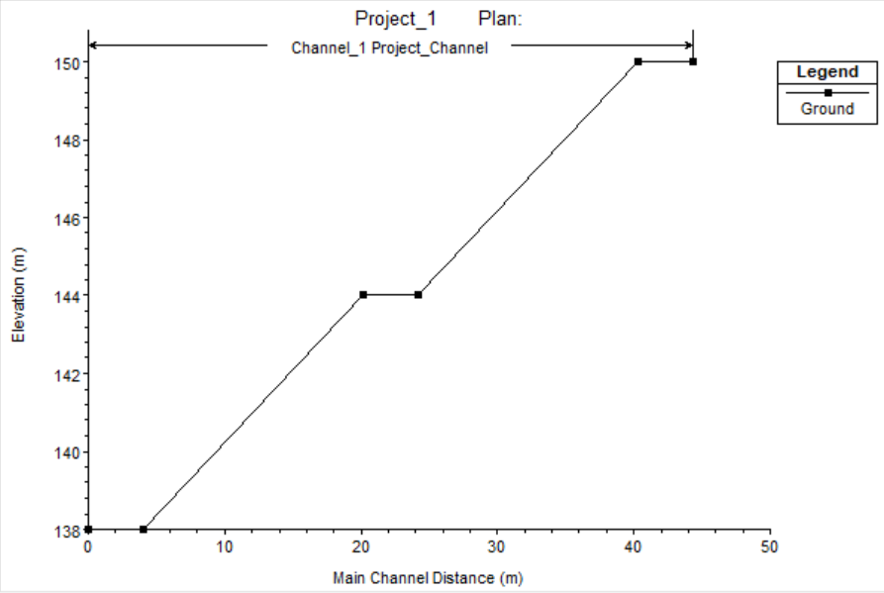

Figure 2.1: Channel Profile

The channel is trapizoidal as shown in Fig-2. No overbank is considered for this model.

Figure 2.2: Cross-section of channel

The 3D view of the model without chute blocks are shown in Fig-3 to have a better visualization on the model. The region from 0 m to 4 m is the riprap region and defined in the model by using Manning’s roughness coefficient 0.04.

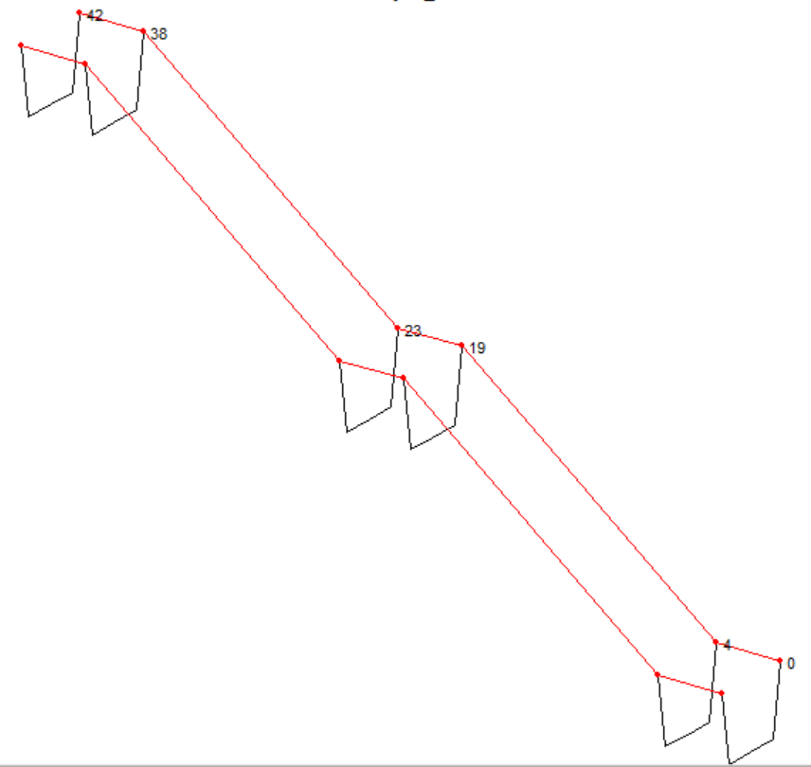

Figure 2.3: Isometric view of channel model(without chute blocks)

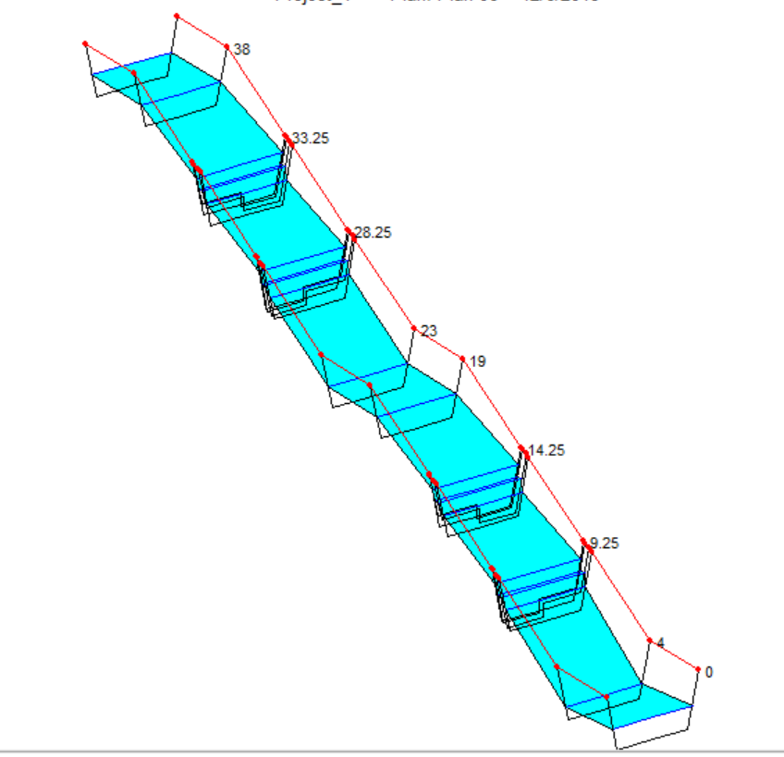

Figure 2.4: Isometric view of channel model(with chute blocks)

## Chapter 3: Results and Discussion

### 3.1 Without Chute Blocks

The following figure shows the water surface profile along channel distance. Different refinement was tried to check for more accurate profile curve. Here, flow is fluctuating between S2 and S3 curve. Because the water depth is fluctuating below the critical depth and for steep channel Yc > Yo. So the flow moving above and below normal depth.

Figure 3.1.1: Water surface profile along channel

As we observe in Fig-3.2 , Froude number is always above 1 and thus having subcritical flow, except near downstream region where the flow becomes subcritical and we notice an adverse M3 curve at the transition and at the downstream M2 curve is noticed.

Figure 3.1.2: Water depth and Froude number

Here, maximumm water depth is 1.16 m (in subcritical region) and the critical height is less than 1 (0..8 m). which is far below the channel height (2 m). Because the channel is steep, we will have supercritical flow (water depth < critical depth). So, we may say the channel is oversized and can be optimized and there is no possibility of flooding.

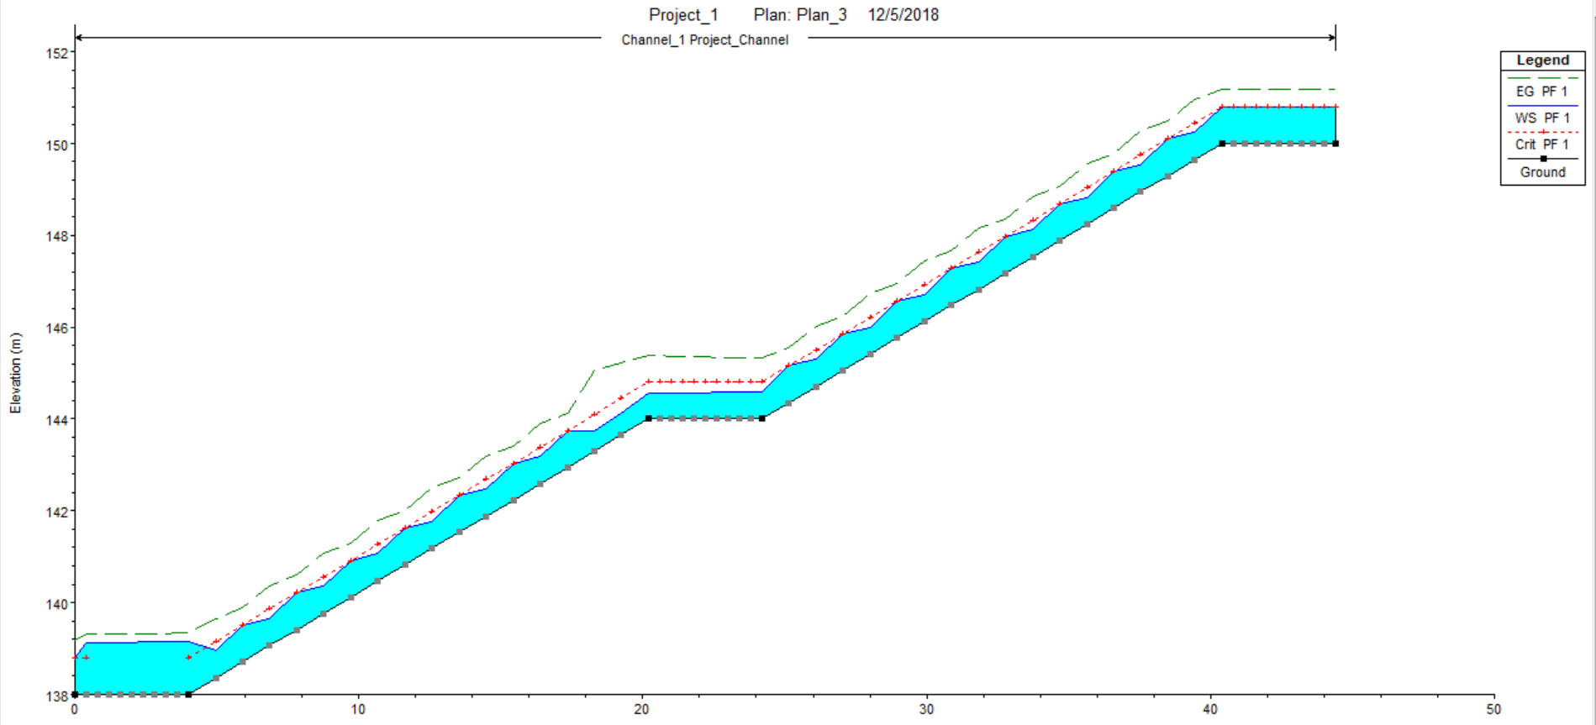

Figure 3.1.3: Channel profile from Hec-Ras

Here, the green dotted line showing the energy gradeline and red dotted line showing critical depth. The flow is critical at upstream, supercritical in clannel length and became subcritical near downstream. The energy line also shows that there is no energy loss at the same elevation.

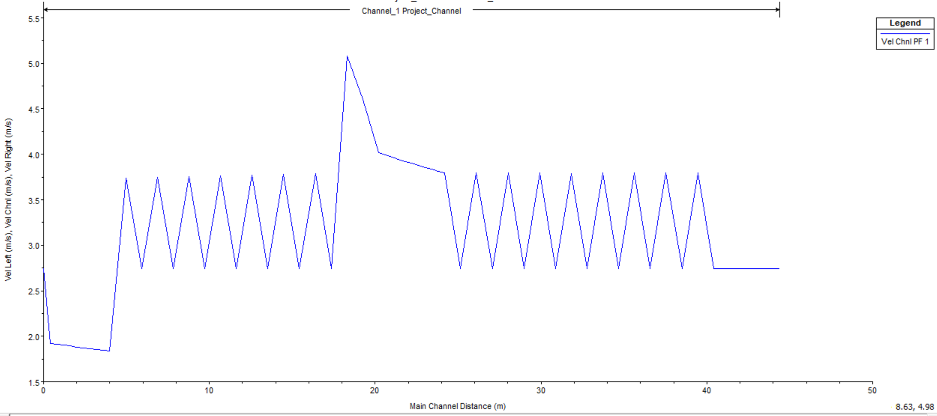

Figure 3.1.4: Velocity profile from Hec-Ras

### 3.2 With Chute Blocks

With chute block, observing the watersurface profile, we notice that there are hydraulic jump occuring at the chute blocks and then the flow became supercritical again. At downstream flow is still subcritical.

Figure 3.2.1: Water surface profile along channel (with chute blocks)

As we observe in Fig 3.2.1, there are four hydraulic jump at all four chute blocks. Flow is mostly supercritical due to steep slope.

Figure 3.2.2: Water depth and Froude number (with chute blocks)

With the chute blocks, observing the water depths, the channel does not seem oversized.

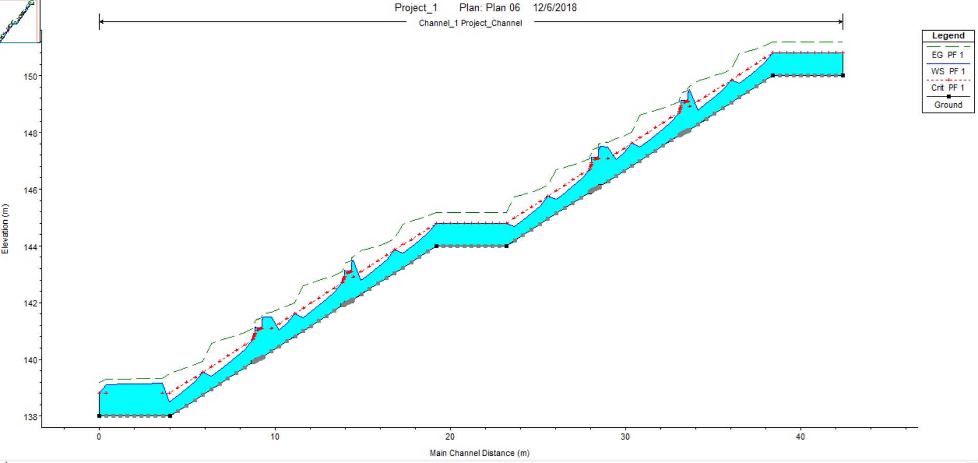

Figure 3.2.3: Channel profile from Hec-Ras (with chute blocks)

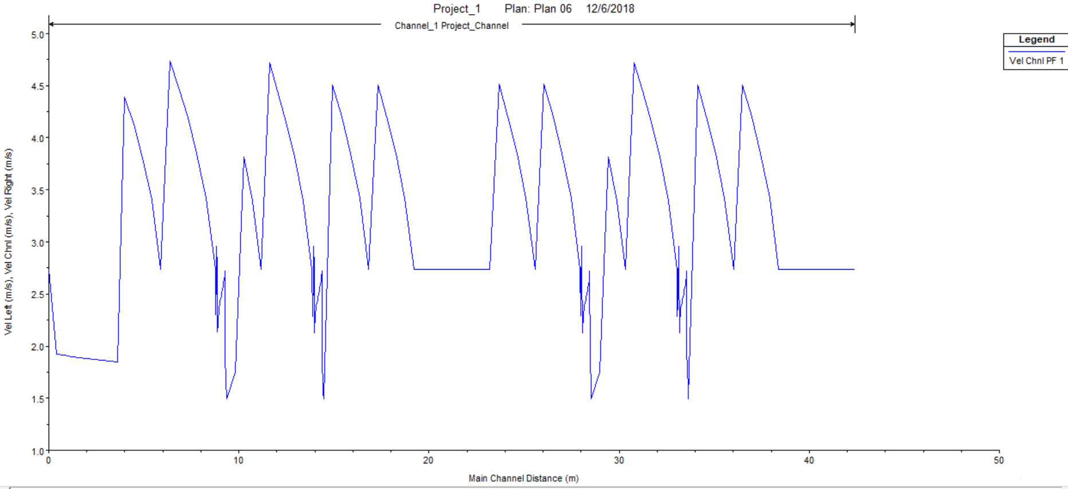

Figure 3.2.4: Velocity profile from Hec-Ras (with chute blocks)

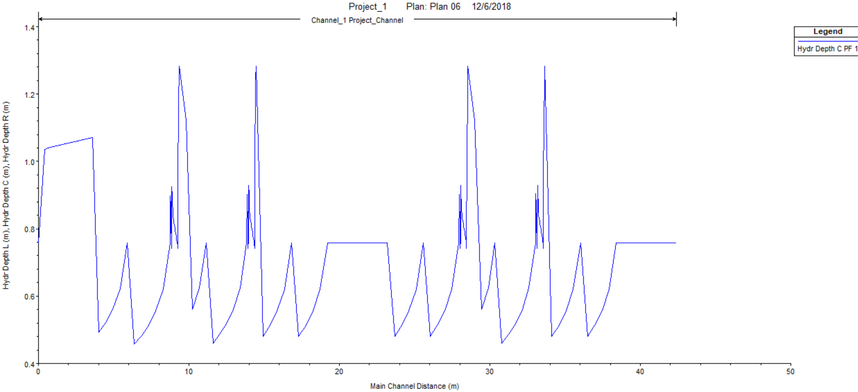

Figure 3.2.5: Hydraulic depth profile from Hec-Ras (with chute blocks)

## Chapter 4: Conclusion

With chute blocks velocty is comperatively high and hydraulic jump occurs which eases energy dissipation. Channel system with chute blocks is preferred due to more control on the flow. The channel is not considered oversized for flow with chute blocks.

Different sizes of chute blocks can the used to analyze in order to optimize the channel flow.